Morning Bakery Website Project Documentation
[Kelompok 7] [2-SIMC]
Team members:
- Yohannes Wahyu Angelio :2531065
- Jayden Lie :2531024
- August Sparkle :2531119
- Jayson Cantriono :2531025
- Carel Febrian :2531147

Wireframe Document
Link gdrive Wireframe : https://drive.google.com/drive/folders/1iJqH6lSMv-iWCe6_WErU0VDxEO6JJFpB?usp=sharing

Sitemap
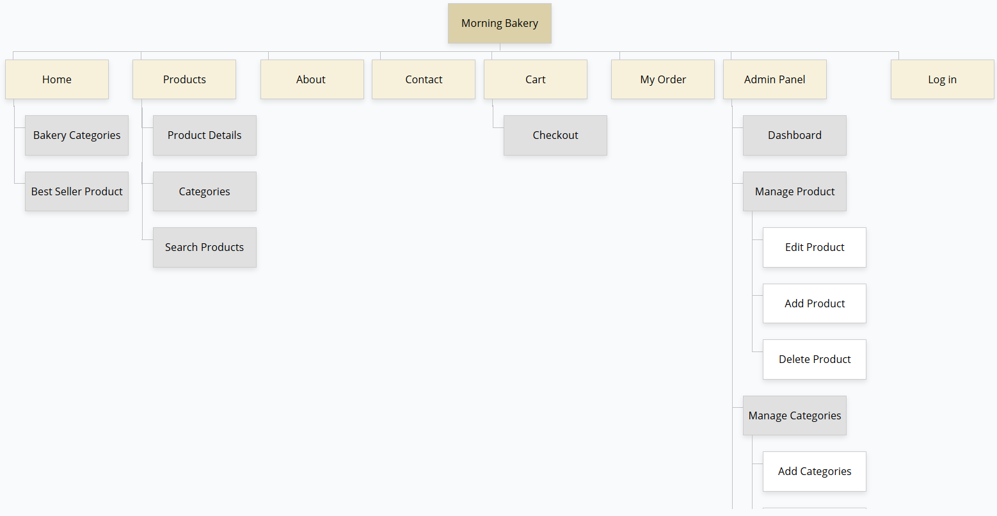
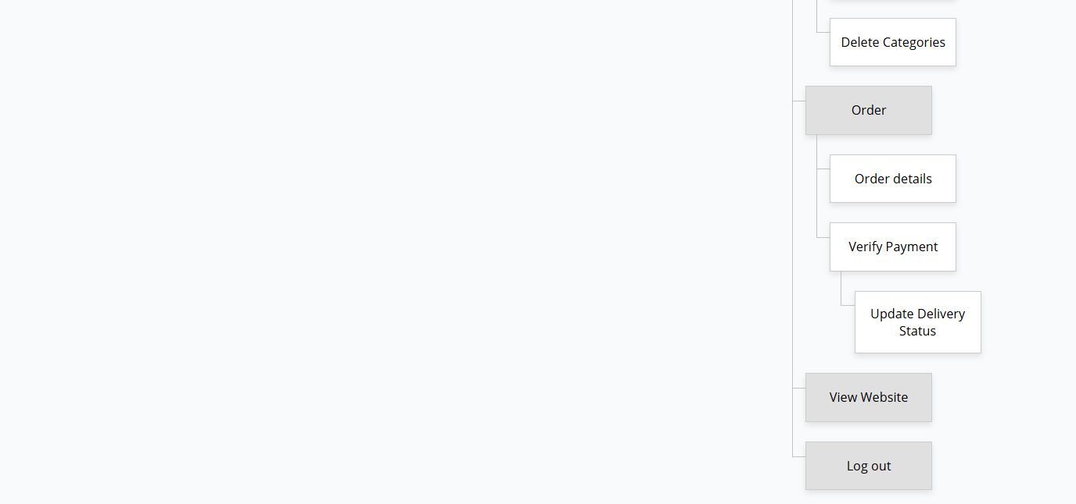

3. Design Rationale Document
Project Overview
PhoneStore is a company profile and product showcase website designed to promote smartphone products and provide company information to customers. The website aims to create a modern, responsive, and user-friendly experience.
Design Objectives
- Introduce PhoneStore as a trusted smartphone retailer
- Display products clearly and attractively
- Provide easy navigation for users
- Support responsive access on desktop and mobile devices
Target Audience
- Smartphone buyers
- Technology enthusiasts
- Customers searching for affordable smartphones
- Online visitors looking for product information
Color Selection
- Blue as the primary color to represent trust and technology
- White for a clean and modern appearance
- Gray for neutral background elements
Typography
- Poppins
- Roboto
Layout Design
- Navigation menu placed at the top
- Featured products displayed on the homepage
- Consistent spacing and alignment
- Responsive grid system for mobile compatibility
User Experience (UX)
- Easy navigation
- Fast access to products
- Clear product information
- Mobile responsiveness
- Simple admin management system
Features
Main Features:
- Homepage
- Product catalog
- Product detail page
- Company information
- Contact page
Admin Features:
- Add products
- Edit products
- Delete products
- Manage categories
Responsive Design
The website is fully responsive using Bootstrap framework.
Technology Stack
Frontend:
- HTML
- CSS
- Bootstrap
- JavaScript
Backend:
- Native PHP
Database:
- MySQL
Version Control:
- GitHub Public Repository
Conclusion
The PhoneStore website is designed to provide a professional company profile and product showcase platform with a focus on simplicity, usability, and responsiveness.

